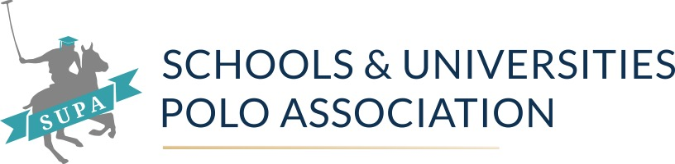

Senior Schools National Summer Championships
Saturday, 15th June 2023
Ground 6, Kirtlington Park Polo Club, Akeman St, Kidlington, OX5 3JQ
https://www.kirtlingtonparkpoloclub.co.uk/
https://what3words.com/curve.reclined.page

If you are running late please call
Caroline on 07889141344 or
Gill on 07887950414

A huge thank you to Kirtlington Park Polo Club for hosting us, after such a wet beginning to the season we are very grateful to everyone at Kirtlington for allowing us to come and play – please respect the site and leave it clean and tidy, do not muck out horseboxes or leave tape lying around.

Please make sure you read all the information in this letter and pass it on to everyone attending (including your horse hirer, coach etc)

We are paper free and all information for the tournament will be on the “Play Polo App”. Please ensure that you download the App prior to your arrival at Kirtlington Park Polo Club. (There will be Wi-Fi routers at the SUPA base camp). This is also a brilliant way for anyone unable to attend the event to be able to see how their team is doing!

WhatsApp – following on from the Universities National Championships, we have a created a WhatsApp group for this tournament, it is purely for information. Please note that you cannot comment on it.

https://chat.whatsapp.com/BdAiVN0zwYXBnjF8k1YI1a

Any changes, or relevant information will be posted via the WhatsApp group.

Start Time

We are starting at 11.30 am promptly. Although we have given timings these are purely for guidance and not written in stone.

It is your responsibility to ensure that your child/children/students are mounted and ready to play a minimum of 1 chukka before their chukka.

The ‘Play Polo’ app is available in the App Store for both Android and Apple or you can follow the link here: https://unitedpolo.page.link/mujE

Hats – Please see the link to the updated hat rules issued by the HPA. All hats must meet HPA requirements and be tagged with the SUPA hat tag, please visit RJ Polo to get this done before getting on any ponies

https://hpa-polo.co.uk/download/2024-Helmet-Rules.pdf

Rules - Please ensure that you have read the rules on our website https://www.supa.org.uk/

Dress code – whites, numbered shirts (no hoodies when riding) knee pads, and long boots or chaps.

Prizes – Prize giving will commence approximately 10 minutes after the final chukka at the SUPA base camp. All teams are expected to attend in their shirts, whites and boots.

General Info

The dreaded weather - as I write the weather forecast for the weekend looks decidedly unsettled. Please remember that it is always at least 3 degrees cooler on the side of a polo pitch and bring plenty of warm clothes and waterproofs.

Food – we are delighted to say our fantastic pizza guys Santina’s will be cooking fresh pizza’s on site from 11.30. They will also have soft drinks.

Merchandise – RJ Polo will be in attendance if you require any kit, we recommend you look at their website and place an order which they can then bring on Saturday. https://www.rjpolo.com/

